Function definition for sierpinski carpet

**Signature, purpose and stub**

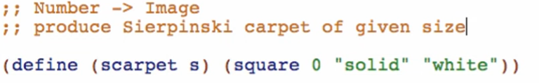

**Examples**

Base case



Next smallest case

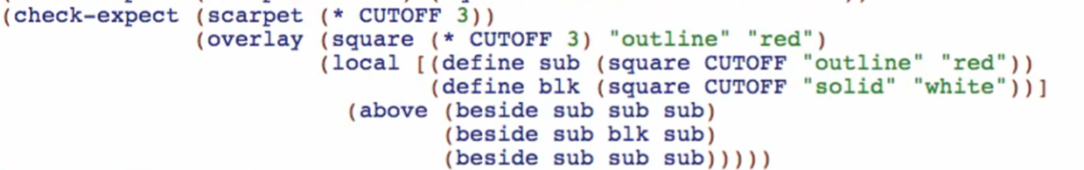

**Template**

Copy and rename functions and natural recursions and parameter

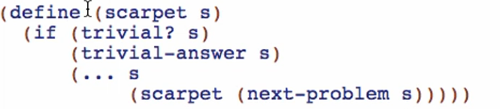

**Code body**

base case

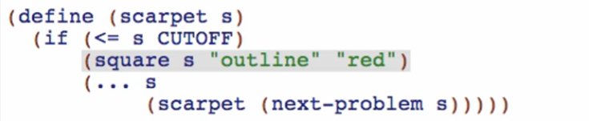

Non-base case

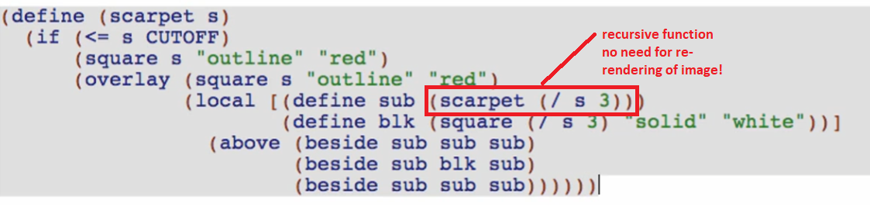

Main idea: yung sides lang ang paulit-ulit ng pattern!

Note: do not ever delete the template for natural recursion. Always trust the natural recursion!